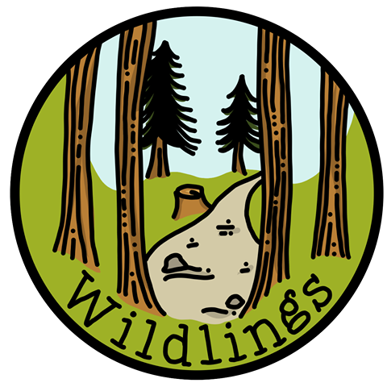

Lunch Box Policy

Policy statement
At Wildlings we recognise our position in having a positive influence on the attitudes that children have towards food and a healthy lifestyle. We will continue to teach and discuss aspects of a healthy lifestyle with the children and we aim to adhere to national guidance on healthy eating. The aim of this policy is to ensure that all packed lunches brought Wildlings are safe, healthy, (based on the national standards set for school lunches) and consumed as part of a positive lunchtime experience
Responsibilities
Record keeping
Upon joining the setting, each child’s individual dietary needs, preferences and any allergies are requested in the All About Me booklet. Allergies are also recorded on our registration form.
Information about children’s individual dietary needs and allergies is clearly displayed on our information sheet which is on the inside door of our cupboard, on the notice board in the main hall and on the “snack board” in the kitchen. All practitioners are fully informed via a post on Band (our communication app for staff). Allergies and dietary needs are also recorded on a child’s Famly profile and families are asked to check that information on their child’s account is accurate and up to date at the start of each term.
Staff must:
- Check for any allergies before serving any food or snacks,
- Where there are children with severe allergies, ensure that separate knives, chopping boards, etc are used where necessary,
- All members of staff must have obtained their Food Hygiene certificate,
- All sharp knives, cleaning products, etc must be kept out of reach of children.

Food hygiene and training
To ensure that food prepared is done so in the best possible conditions all of our staff are required to obtain a Safe Food Hygiene certificate within the first three months of employment. This should be updated every 2 years.
To maintain high levels of hygiene in food preparation areas we will:
- Provide staff with procedures for food preparation.
- Ensure that food preparation areas are kept clean.
- Check upon delivery all food purchased for expiry dates and quality.
- Store foods in such a way that those with the longest shelf life are stored behind one another.
- Check all food at the time of use to ensure that it is still in date.
- Food which has been opened is labelled with the date opened and date for disposal (in accordance with the instructions on the packaging).

Snack time
Snacks provided will be nutritious and of high quality and will not contain large quantities of saturated fat, sugar, salt, artificial additives, preservatives and colourings. In addition, foods described as ‘low fat’ will not be used nor will any food containing nuts or nut products. Children will generally receive fruit and vegetables at snack time as part of their recommended 5 portions a day and we aim to provide a variety throughout the week. Portion sizes will be appropriate for the child’s needs
Drinks
We ask that children bring a water bottle in with them each day. These are to be placed in the grey box on the lunch trolley when at the hall. This is stored in the same place each day, so the children are able to get water for themselves whenever they are thirsty.
During outdoor sessions water bottles are kept within the children’s personal bags. Wildlings also bring a large flask of cold water to the outdoor sites to top up children’s water bottles if necessary so they have access to fresh drinking water throughout the day. Milk is also available at snack time. During the colder winter months warm drinks such as hot chocolate, warm milk, warm cordial and fruit juice may be offered to children to ensure that their core temperature remains warm. Staff inform children that they can ask for more water at any point during the day.
Meal times
We organise meal and snack times so that they foster independence and are social times in which children and staff participate. Appropriate staffing levels are always maintained and children remain in clear sight during mealtimes. There is always a pediatric first aider present at all mealtimes. We discourage children from sharing their food with others.
During hall sessions children sit in small groups at tables. There will be a practitioner sat on each table with them in order to model social behaviours and encourage the development of independence. A selection of different snack items are placed in the middle of the table for the children to choose from. During outdoor sessions we all sit together on a picnic blanket or on logs/rocks. The practitioners always sit with the children and this is a social time.
We encourage children to understand when they are full. This means that while we encourage children to eat a healthy amount they may not always eat everything in their lunchbox.
Food and drink in packed lunches
All children attending Wildings for a full day will need to bring a packed lunch and drink. Please ensure that boxes, bottles etc are all labelled with your child’s name. Fridge space is limited and so you are advised to send packed lunches in insulated bags with freezer blocks on warmer days. A good substitute for a freezer block is a frozen drink which will defrost during the morning. We are unable to warm food up, so if you would like your child to have a warm lunch please bring it ready warmed in a thermal insulated flask.
Wildlings will provide a place and adequate time for children to eat a packed lunch.
Wildlings will encourage parents to consider the guidelines for a healthy packed lunch listed below. These are guidelines not rules. However, we feel that consideration of these guidelines will support the Wildlings community in developing healthy eating habits.
Guidance recommends that packed lunches include:
- At least one portion of fruit and one portion of vegetables each day e.g. carrot sticks, cucumber, a small apple, pear or orange, a banana, dried fruit, mini tomatoes, mango slices.
- A source of non-dairy protein such as meat, fish or vegetarian protein e.g. chicken, turkey, ham, beef, tuna, lentils, kidney beans, chickpeas, falafel, soya, tofu, houmous.
- A starchy food e.g. bread, pasta, rice, crackers, rice cakes, oat cakes, pitta bread, tortilla wraps.
- Dairy (or vegan alternative) e.g. cheese, yoghurt, fromage frais
- A drink of water. An additional drink of milk, yoghurt drink or smoothie could be added. No fizzy drinks and avoid sweet drinks such as squash or juice. Please do not pack glass bottles.
Other considerations
- Please limit sweet foods and chocolate. It is recommend cake or biscuits are occasional and limited to one item.
- Savoury crackers or bread sticks are good alternatives to salty foods such as crisps.
- High fat meat products such as sausage rolls, individual pies and sausages should only be included occasionally.
- Children will be encouraged to eat their savoury food first. We teach children that healthy eating is about having a varied and balanced diet.
- According to health and safety guidelines small items such as grapes and tomatoes should be cut in half vertically to prevent the risk of choking.
Bringing food in to share
Families and children celebrate birthdays and other special cultural events and sometimes ask if they can provide a treat to be shared with the other children. We acknowledge that this is an important aspect of PSED and supports relationships between our children and families. We ask that items such as cake or sweets are limited; children could choose to bring non-food items such as stickers to share instead to celebrate. If you do wish to send in food items we do ask that you first speak to staff for information on allergies and please provide a full ingredient list when giving the food to a member of staff.
Special diets and allergies
Wildlings recognises that some children may require special diets that do not allow for the guidelines to be adhered to. Where there is a child or children with a severe allergy attending our setting, we reserve the right to amend our Lunch Box policy to ensure their safety. We will always inform parents via Famly if changes are necessary.

Thank you for your cooperation.

Date Created: January 2023
Reviewed and amended date: September 2025

